Name: VALLI DEVI K
Batch: 11
Date: 16/08/2025

- Install maven but before deployment it should get approved.

• Azure CLI installed and authenticated (az login)
- ✅ Terraform installed (terraform -v)
- ✅ Active Azure subscription
- ✅ A working directory for your Terraform files
📁 Step 1: Set Up Your Terraform Configuration
Create a new folder and initialize your Terraform project:
mkdir acr-terraform && cd acr-terraform
Create a file named main.tf and add the following:
terraform { required_providers { azurerm = { source = "hashicorp/azurerm" version = "~> 3.0" } } } provider "azurerm" { features {} }
📦 Step 2: Define Resource Group and Container Registry
Add this to main.tf to create a resource group and ACR:
resource "azurerm_resource_group" "rg" { name = "rg-container-registry" location = "East US" } resource "azurerm_container_registry" "acr" { name = "mysecureacr${random_string.suffix.result}" resource_group_name = azurerm_resource_group.rg.name location = azurerm_resource_group.rg.location sku = "Standard" admin_enabled = false }

Add a random suffix generator to ensure uniqueness:
resource "random_string" "suffix" { length = 5 upper = false special = false }
🔐 Step 3: Secure Access with Azure AD (Optional but Recommended)
If you're integrating with Azure AD for secure access control:
resource "azurerm_role_assignment" "acr_pull" { principal_id = "" role_definition_name = "AcrPull" scope = azurerm_container_registry.acr.id }
Replace with the service principal or user object ID.
📤 Step 4: Output Registry Details
Add this to outputs.tf:
output "acr_login_server" { value = azurerm_container_registry.acr.login_server }
🚀 Step 5: Initialize and Apply
Run the following commands:
terraform init terraform plan terraform apply
Confirm when prompted. Terraform will provision the resource group and ACR.
✅ Step 6: Verify and Use
After deployment:
- Use az acr list to verify the registry
- Push images using Docker:
az acr login --name docker tag myimage /myimage:v1 docker push /myimage:v1
🔄 Optional Enhancements
- Enable geo-replication for multi-region deployments
- Integrate with Key Vault for secret management
- Add lifecycle rules for image retention

If you'd like, I can help you modularize this into reusable Terraform modules or integrate it into your CI/CD pipeline with approval gates and secure variable injection. Want to take it further?

create a docker image and verify running

- Configure Approval in Azure DevOps UI
- Approvals aren’t defined in YAML — they’re set in the portal:
- Go to Pipelines > Environments
- Select your environment (PreDeploy)
- Click Approvals and checks
- Add a Manual Approval
- Choose who must approve (user or group)
- Once this is set, Azure DevOps will pause the pipeline at that stage until approval is granted.
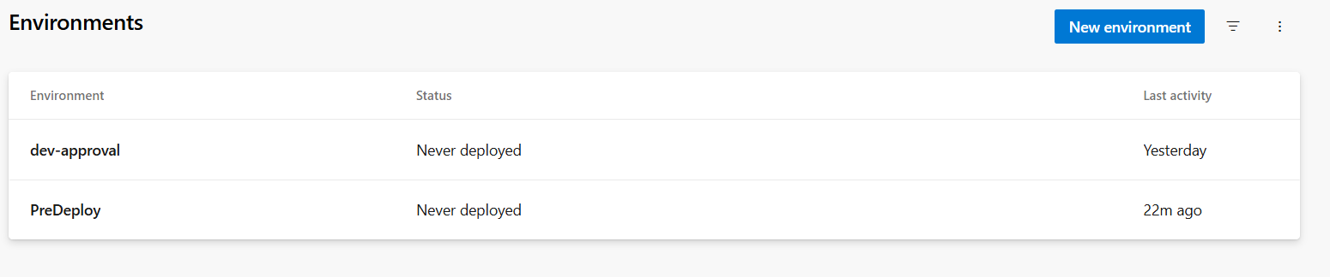
- Create New pipeline
- Configure pipeline with required details
- This structure ensures:
- The Approval stage waits for the Build to succeed
- The PreDeploy environment triggers the manual approval
- Only after approval, the Deploy stage runs
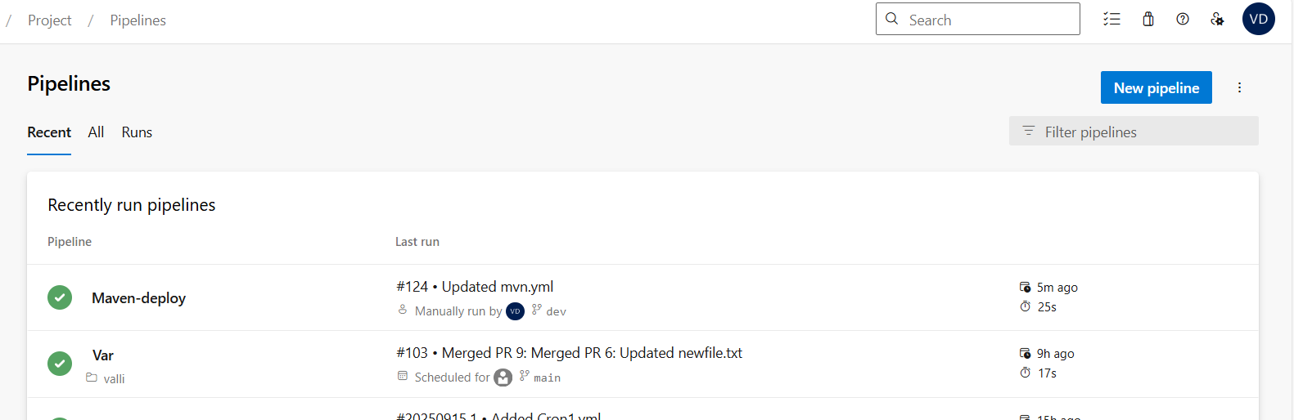
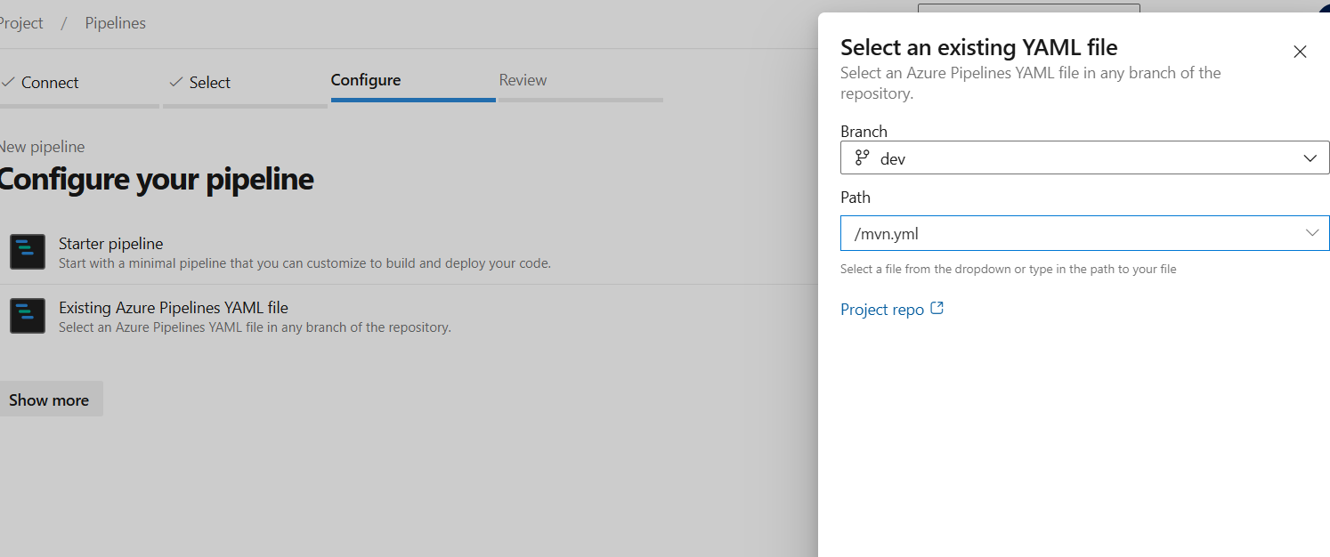
trigger: none
pool:
name: pool1
stages:
- stage: Build
jobs:
- job: BuildJob
steps:
- script: mvn clean package -X
workingDirectory: $(Build.SourcesDirectory)/your-subfolder
- stage: Approval
dependsOn: Build
condition: succeeded()
jobs:
- deployment: WaitForApproval
environment: 'PreDeploy'
strategy:
runOnce:
deploy:
steps:
- script: echo "Waiting for approval..."
- stage: Deploy
dependsOn: Approval
condition: succeeded()
jobs:
- job: DeployJob
steps:
- script: mvn deploy

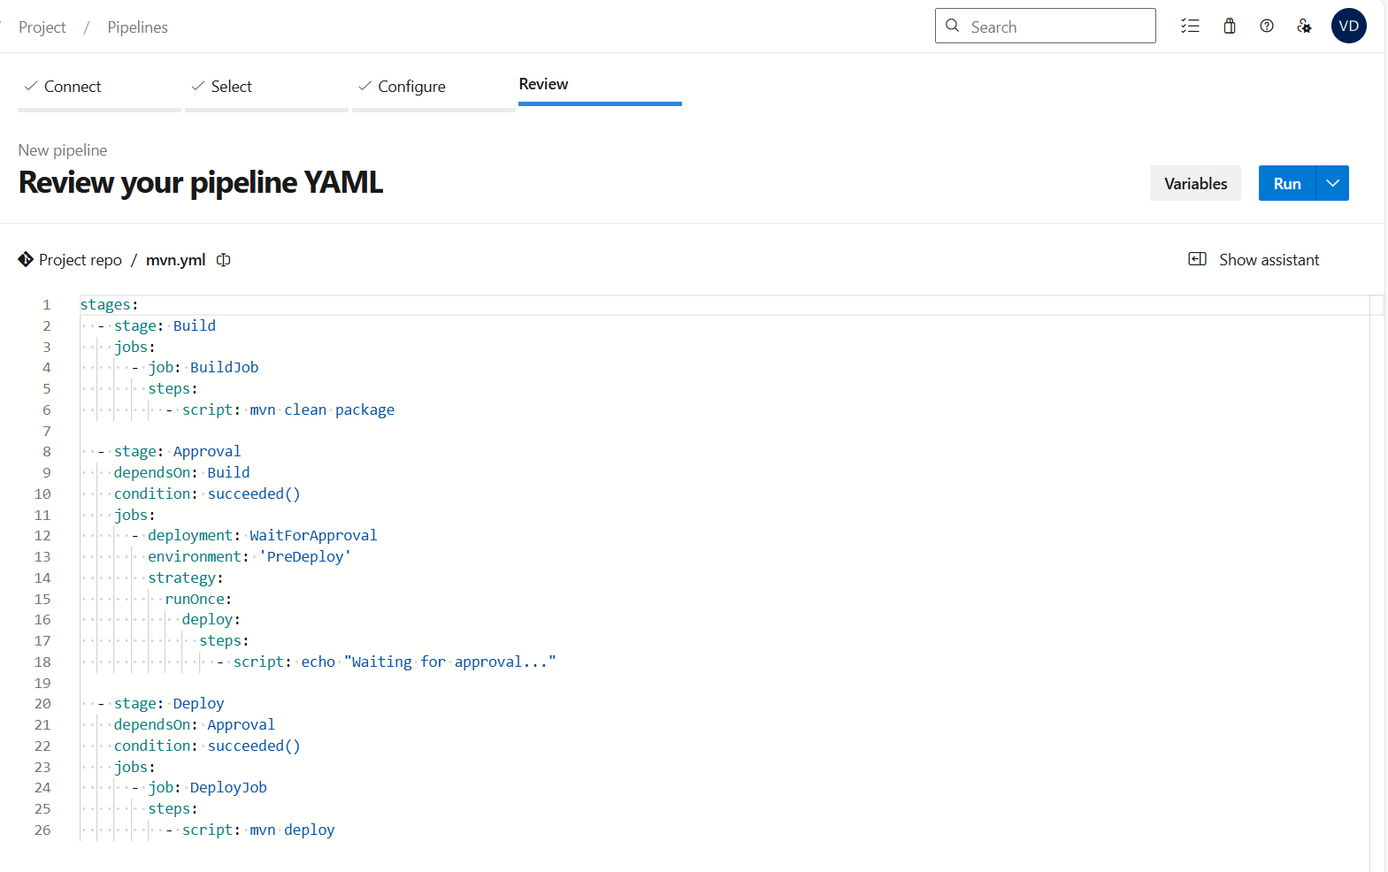

- Check the pipeline status
- Artifact has been published
- Post-job approval is done
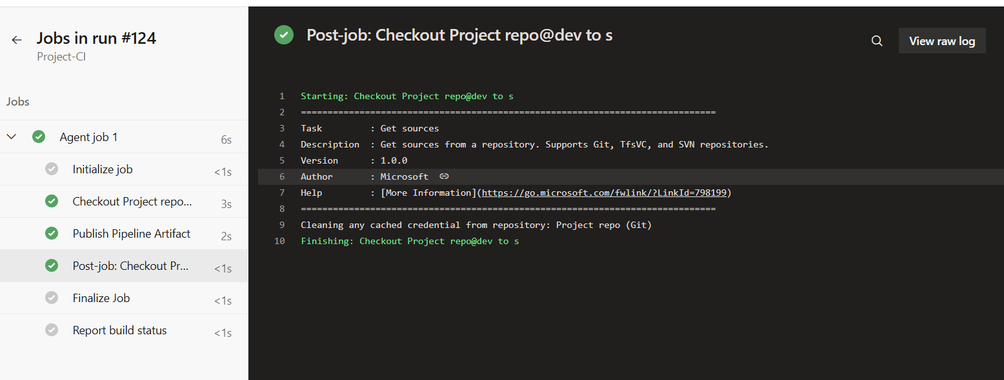
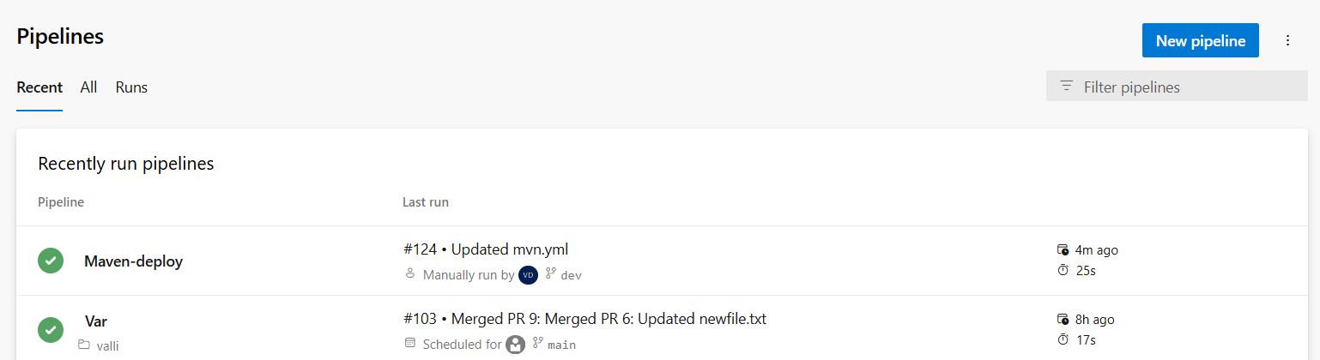

- How to use pat tokens in pipeline and secret in variable group in azure devops
Generate and Store Your PAT Token
- Create a PAT:
- Go to your Azure DevOps profile → User Settings → Personal Access Tokens
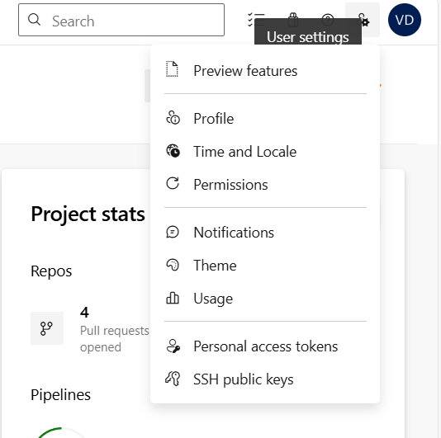
- Click + New Token
- Choose scopes (e.g., Code: Read & Write for Git access)
- Set a short expiration (e.g., 30–90 days)
- Copy the token immediately—it's shown only once 8K6eN33B0LTGLHdtPur7HV05o5BXghq460YNZJxCFIsPMQ8EDQwdJQQJ99BIACAAAAAAAAAAAAASAZDO37hs
- Store PAT as a Secret Variable:
- Go to Pipelines → Library → + Variable Group
- Create a variable like gitPatToken
- Mark it as secret
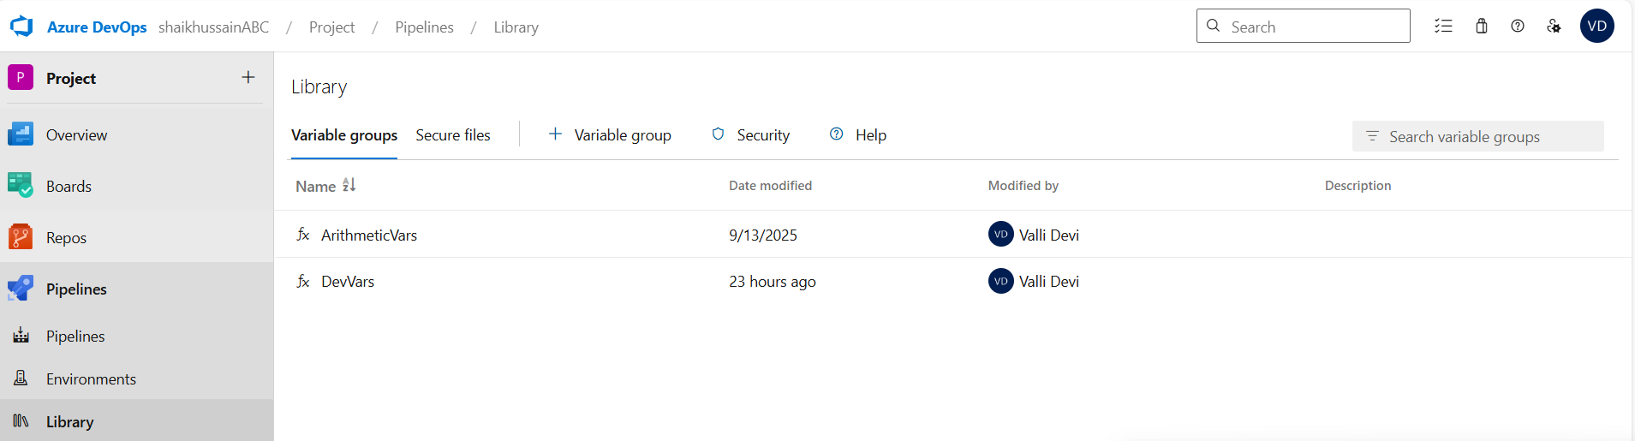
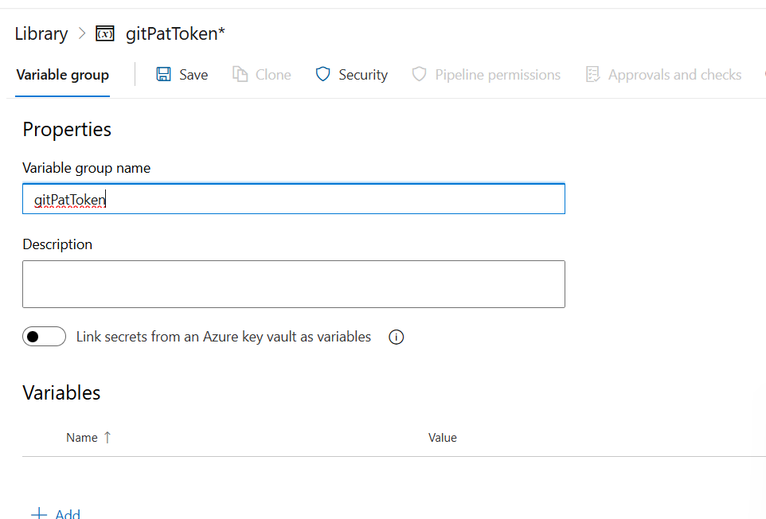

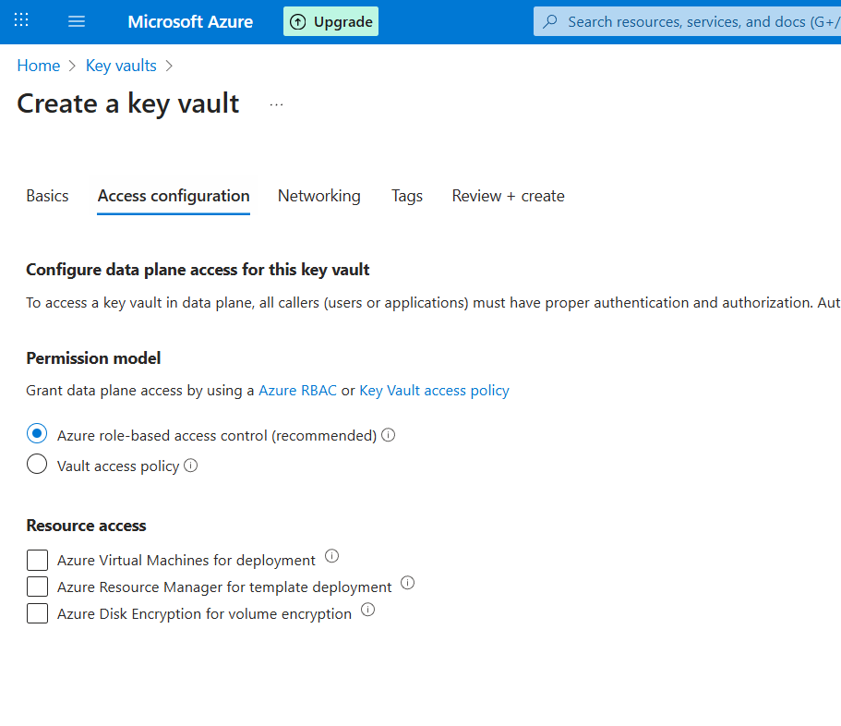
- Provide all required details
- Basic, Access configuration, Networking
- Review+Create to generate key-vault
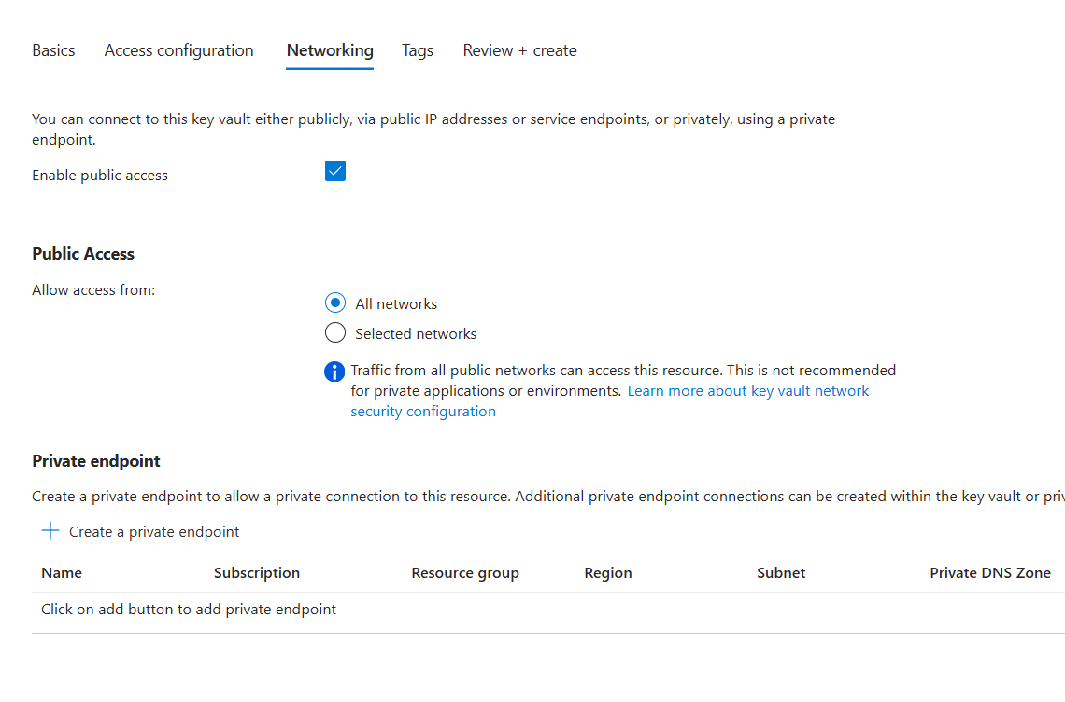
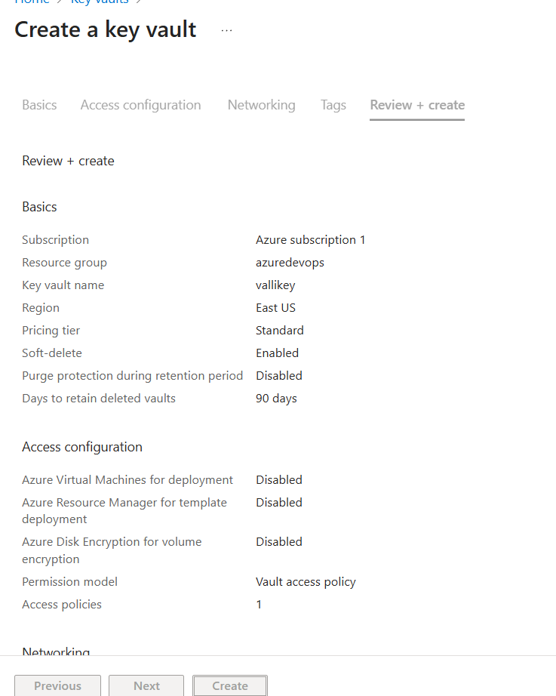

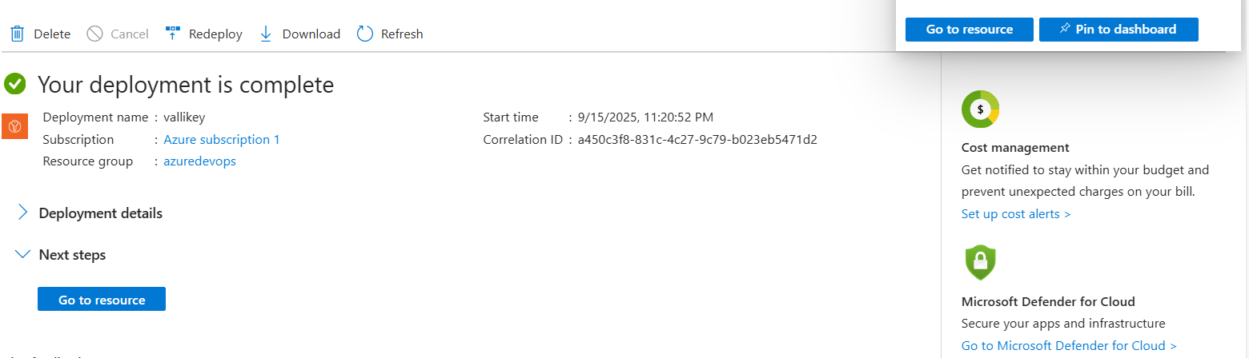
Avoid Hardcoding or Logging
- Never hardcode the PAT in your YAML or scripts
- Avoid echoing it or printing it to logs
- Use secure tools (like curl, az devops login, etc.) that accept tokens via environment variables or headers
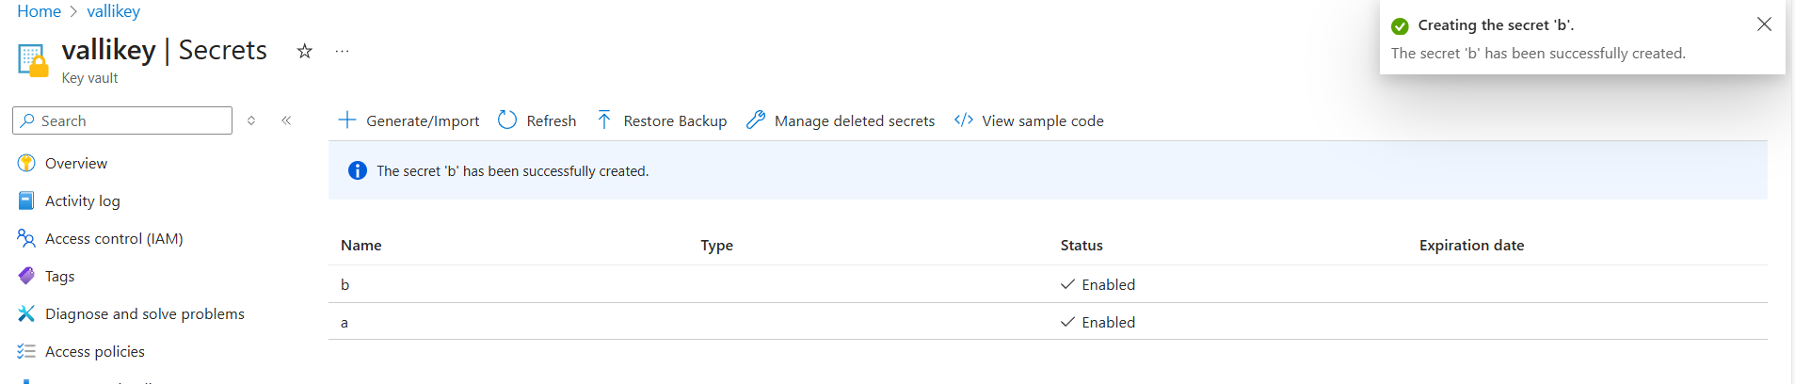

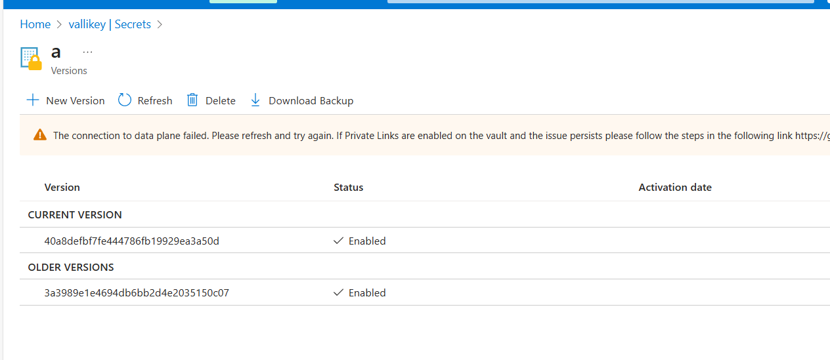

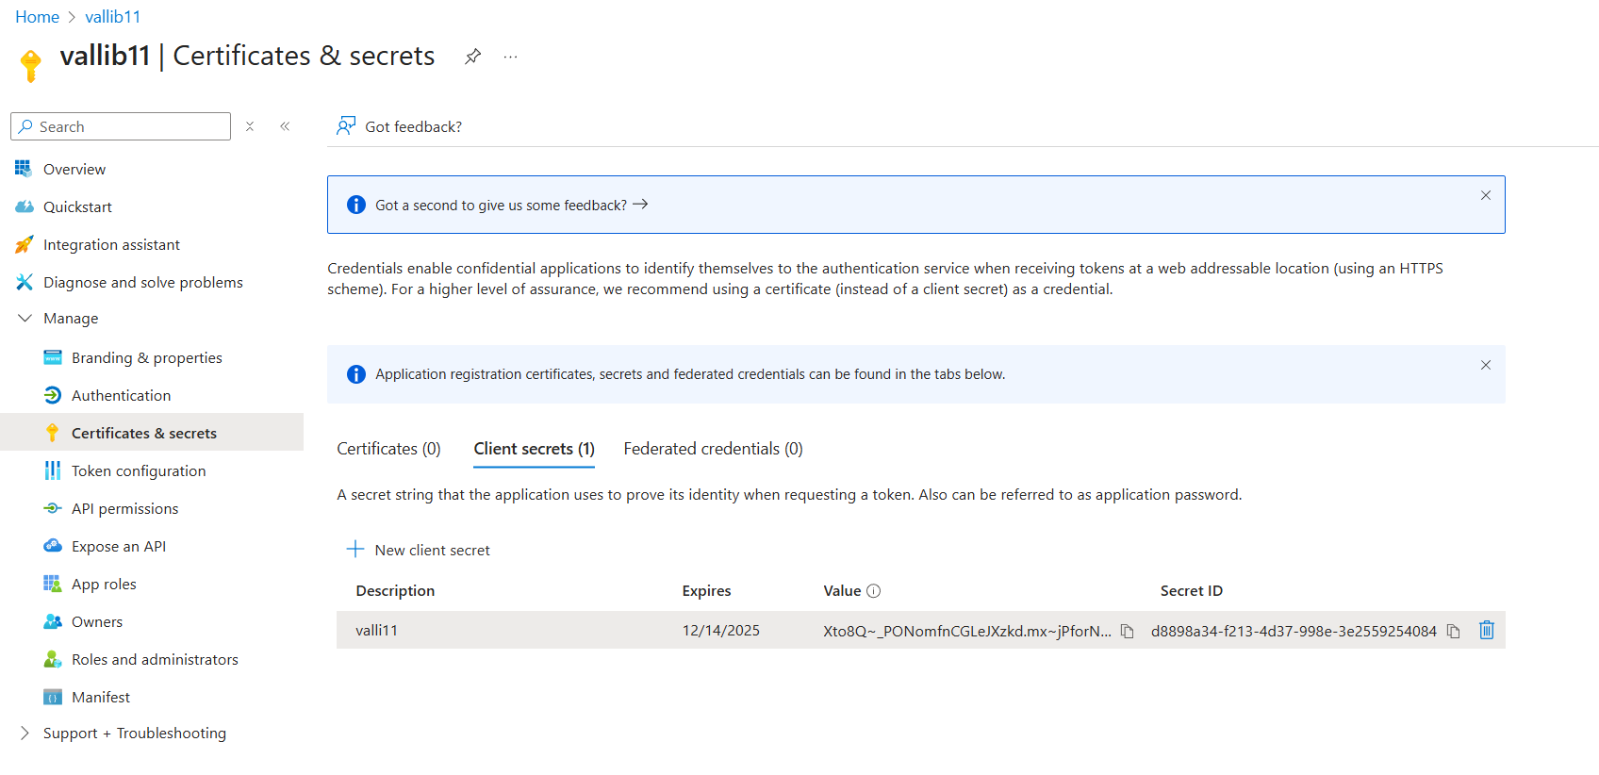
- Create New Pipeline
- If you're using the PAT to access Azure Repos or REST APIs from scripts, this setup is secure as long as you treat the token like a password. For even stronger security, consider integrating Azure Key Vault with your pipeline to manage secrets centrally.
